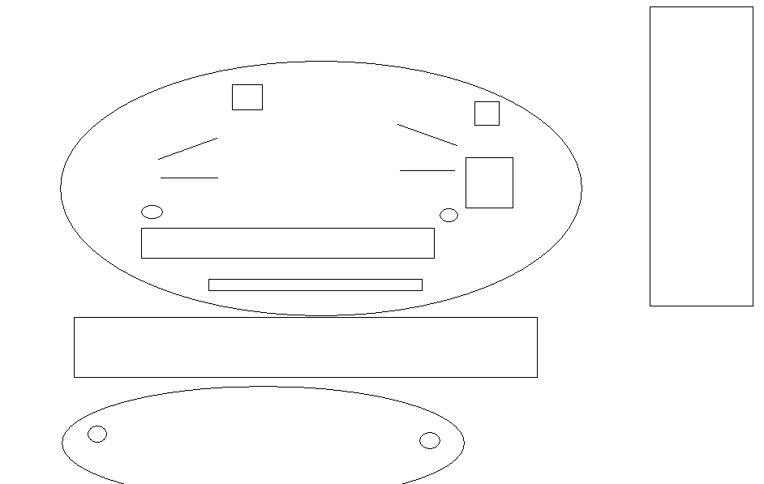

Javelin

4

Long Jump/Triple Jump

High Jump

7

2

6

1

Javelin

8

9

10

5

3

Shot Put

Straight track – 100m and Hurdles.

Shot Put

1500m

200m

Grandstand

Canteen and Toilets

Grandstand

Discus

Area

Car

Park